**SAMAJIK SURAKSHA YOJANA USER MANUAL**

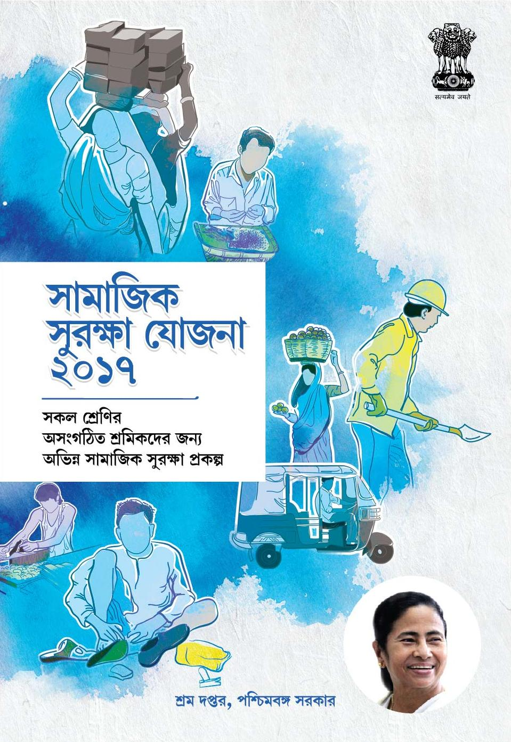

**Document Revisions**

|  |  |  |
| --- | --- | --- |
| Date | Version Number | Document Changes |
| 14/10/2017 | 1.0 | First Release Version |
|  |  |  |
|  |  |  |
|  |  |  |
|  |  |  |
|  |  |  |
|  |  |  |
|  |  |  |
|  |  |  |

Table of Contents

1. Super Admin 4

1.1 Login 4

1.2 Dashboard 5

1.3 User Management 5

1.3.1 New User Registration 5

1.4 User Profile Edit 6

1.5 User Password Change 7

1.6 User Privilege 8

1.7 Notification 9

1.8 Reports 10

1.8.1 Detailed Report 10

1.8.2 Abstract Report 11

1.9 Edit Profile 12

1.10 Change Password 13

1.11 Beneficiary Registration 13

1.12 Logout 15

2. Deputy Labour Commissioner 16

2.1 Login 16

2.2 Dashboard 17

2.3 Reports 17

2.4 Notification 18

2.5 Edit Profile 18

2.6 Change Password 20

2.7 Beneficiary Registration 20

2.8 Logout 21

3. Assistant Labour Commissioner 23

3.1 Login 23

3.2 Dashboard 24

3.3 Registration 24

3.4 Reports 25

3.5 Notification 26

3.6 Edit Profile 27

3.7 Change Password 28

3.8 Beneficiary Registration 28

3.9 Logout 29

4. Inspector 31

4.1 Login 31

4.2 Dashboard 32

4.3 Application Status 32

4.4 Reports 35

4.5 Notification 36

4.6 Edit Profile 37

4.7 Change Password 38

4.8 Beneficiary Registration 38

4.9 Logout 40

5. SLO 41

5.1 Login 41

5.2 Dashboard 42

5.3 Reports 43

5.3.1 Payment Report 44

5.3.2 User Report 44

5.4 Registration 45

5.4.1 Beneficiary Registration 45

5.5 Edit Profile 47

5.6 Change Password 47

5.7 Logout 48

6. Beneficiary 48

6.1 SSY Portal 49

6.2 Apply Online 49

6.3 Registration Process for Existing Beneficiary 50

6.4 Registration Process for New Beneficiary 52

6.5 Login 55

6.6 Dashboard 55

6.7 Edit Profile 57

6.8 Change Password 57

6.9 Logout 58

# 1. Super Admin

## 1.1 Login

The Super Admin can log into the SSY portal by clicking on the Login link in the homepage

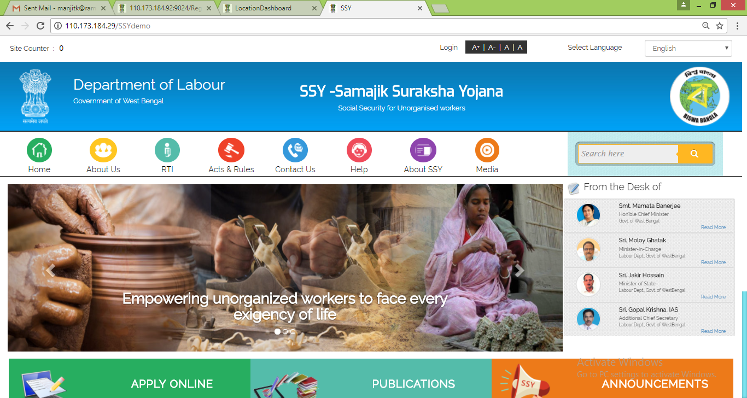

This will bring up the login prompt as shown below. Being departmental user the DLC should select the Department option and input user id and password received through SMS and then click on Login button

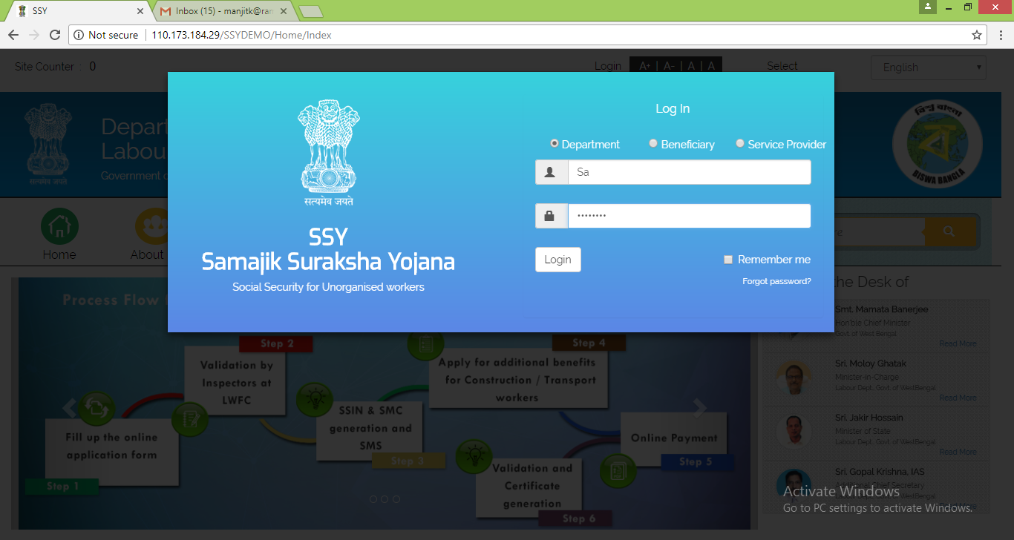

## 1.2 Dashboard

Super Admin is provided a dashboard for Scheme wise Received Details, Approved Details, Pending Details, Rejected Details, Total Application Request and SSY Card Issuance Status

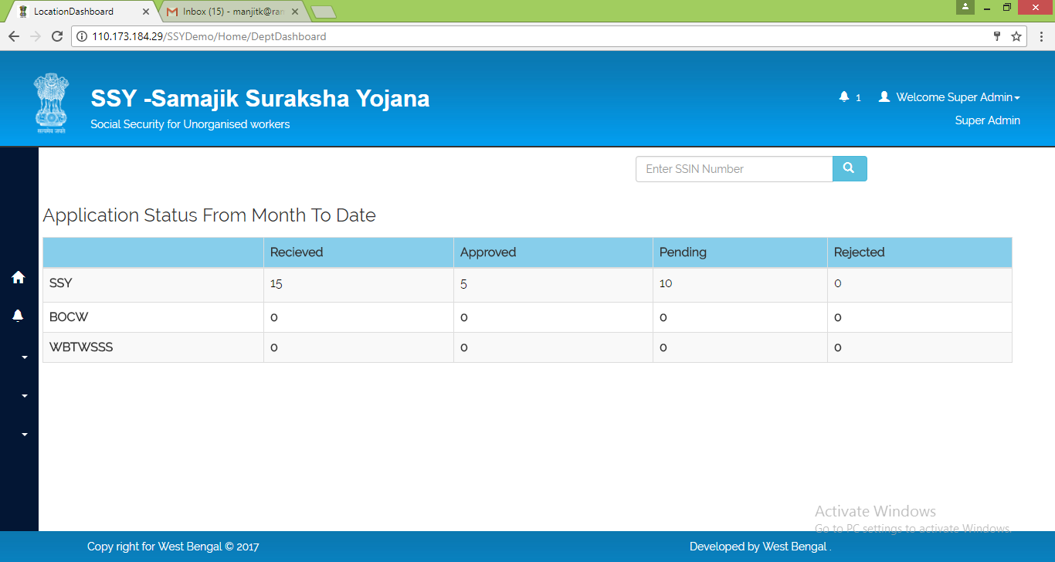

## 1.3 User Management

### 1.3.1 New User Registration

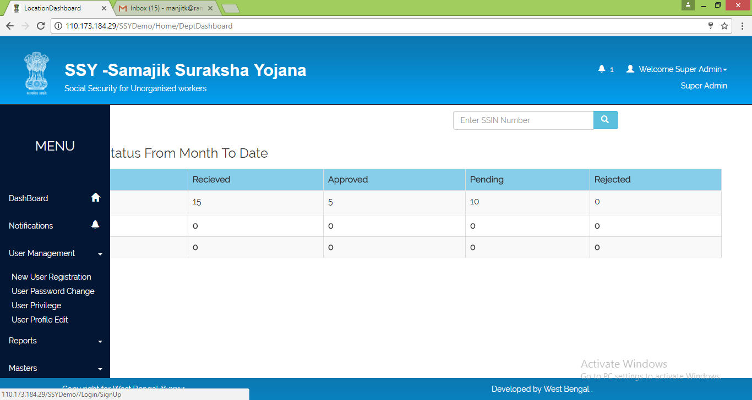

|  |
| --- |
| This module is to assign privileges to the user type and can add or remove based on the requirement. |
| 1. Super Admin able to create User Id for department users like DLC, ALC, Inspector etc. 2. Captures Name, designation, Mobile Number, e-mail Address 3. Allocates the Role, and assign jurisdiction 4. On successful registration, Login Credentials will be sent to registered Mobile Number. 5. There is an option, Forcibly Change Password - on successful login with provided credentials, User has to change password using the Change Password module |

## 1.4 User Profile Edit

|  |
| --- |
| 1. This module is to update User Profile like. First Super Admin has to enter mobile number of the concerned user and click on Get Details to fetch all the details, then perform any of the following actions  a. Any Name or designation details mismatch  b. Change the location from one to another 2. Capture Mobile Number and retrieve User details from SSY database 3. Update necessary change and intimate respective user   1.5 User Password Change |
| 1. In case User Forgot or any other scenarios, User Password Request to Super Admin 2. Capture User Mobile Number and retrieves Name and designation to confirm 3. Capture New Password and update |
| 1.6 User Privilege This module is used for configuring privileges based on user type. The Super Admin need to select the user type and configure the privileges assigned related to different features and functionalities by choosing between Full Access and No Access     1.7 Notification 1. This module is to circulate department wise and User wise Notifications and Circular 2. Select department or Portal 3. Upload document or capture the content and submit 4. Respective information will be displayed respective user login page |
|  |
| 1.8 Reports Requisite MIS Reports are provided under Reports section   1.8.1 Detailed Report The Super Admin user can use the filters to generate reports as per requirement   1.8.2 Abstract Report The user can use this district wise application details report under this section    The user can click on each district to view sub division wise details under that district |
|  |
|  |

The user can click on each sub division to view location wise details under that sub division

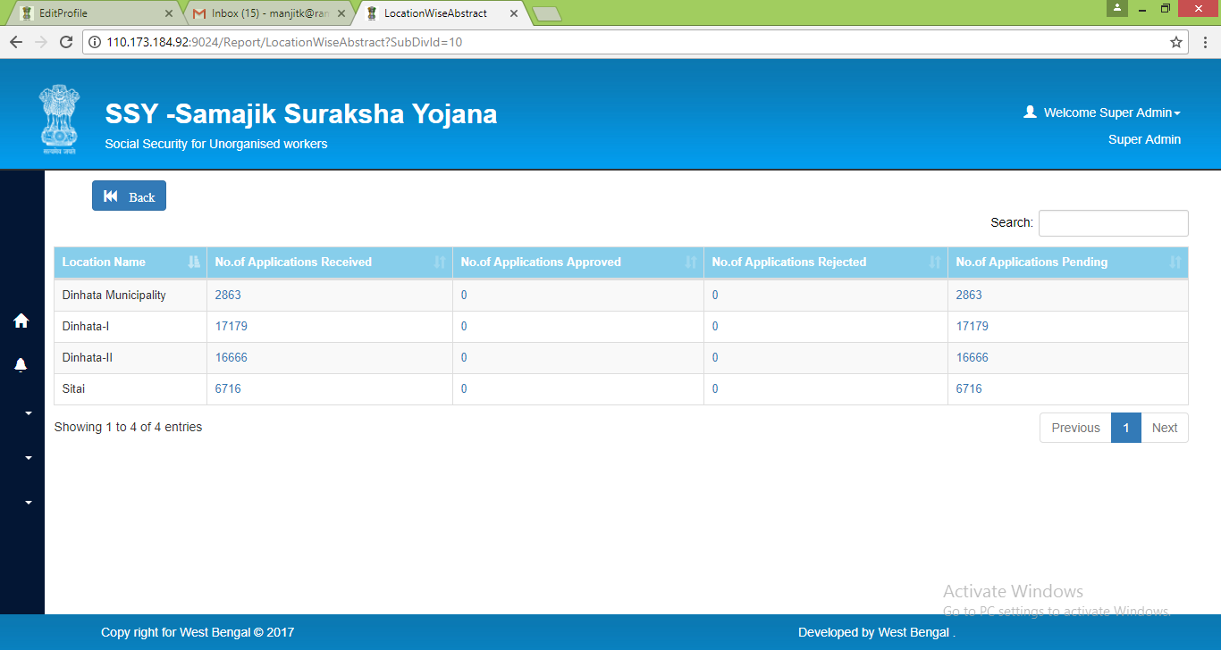

## 1.9 Edit Profile

|  |
| --- |
| The Super Admin user can access edit profile module and change password modules from top right corner of the dashboard itself |
| Edit Profile module could be used to change own profile details   1.10 Change Password Change Password module is to update existing password with new password |

## 1.11 Beneficiary Registration

Super Admin can register beneficiary from their dashboard using the “Ben Registration” module

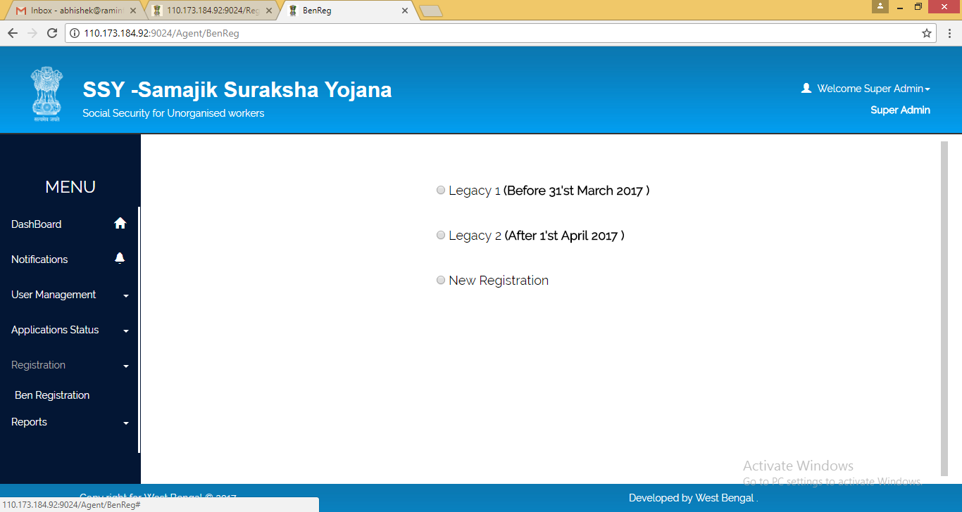

Under each of the three different registration options namely,

* Legacy 1 (Before 31'st March 2017 )
* Legacy 2 (After 1'st April 2017 )
* New Registration

user has option to choose between Bulk Upload or Single Registration

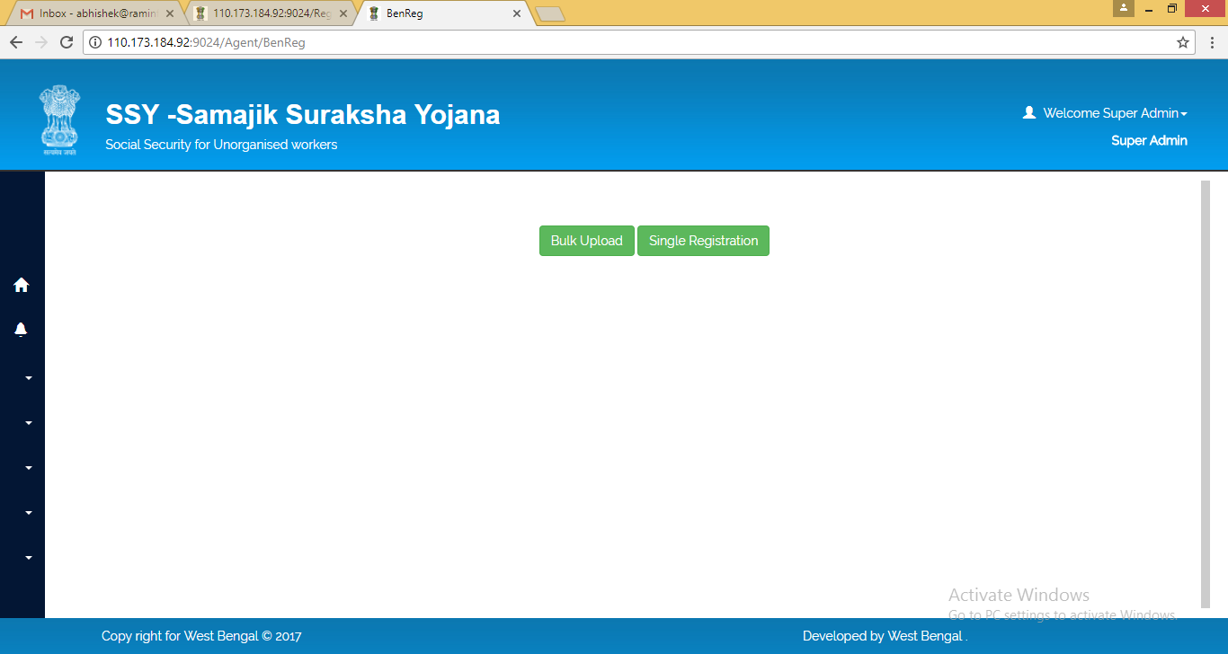

On selecting Bulk Upload the user is redirected to a page with detailed instruction about the bulk upload procedure

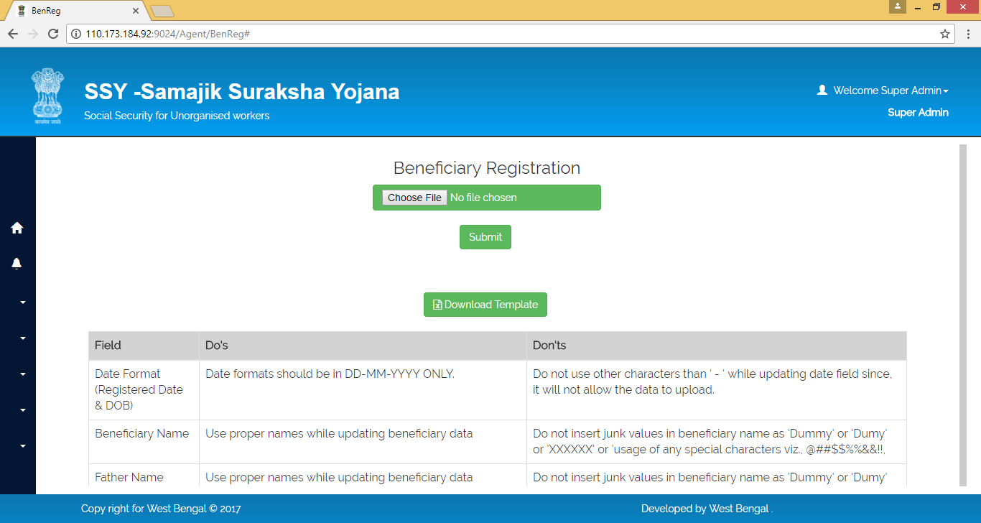

|  |  |  |
| --- | --- | --- |
| FIELD NAME | DESCRIPTION | REMARKS |
| Download Template | Button to generate beneficiary bulk upload format | * Clicking this button will download bulk beneficiary upload excel format file in user’s local system |
| Choose File | Upload location of duly filled in bulk beneficiary upload data file | * User can select path of his local machine where duly filled in bulk beneficiary upload data file is saved |
| Submit | Button to upload beneficiary bulk data in SSY database | * Clicking this button will upload the bulk beneficiary data file in SSY database |

On selecting Single Registration the user is redirected to a page from where single user registration can be done. Details of registration process are described as follows,

* New Beneficiary Registration (Refer Section 6.4 of this document)
* Existing Beneficiary Registration (Refer Section 6.3 of this document)

## 1.12 Logout

The Super Admin user can log out of the SSY application by clicking on the Logout link

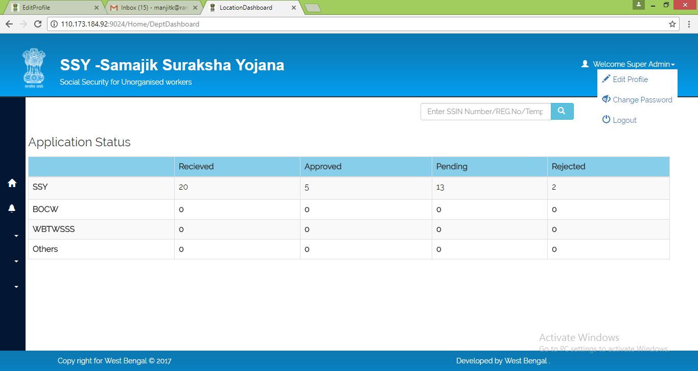

# 2. Deputy Labour Commissioner

## 2.1 Login

The Deputy Labour Commissioner can log into the SSY portal by clicking on the Login link in the homepage



This will bring up the login prompt as shown below. Being departmental user the DLC should select the Department option and input user id and password received through SMS and then click on Login button

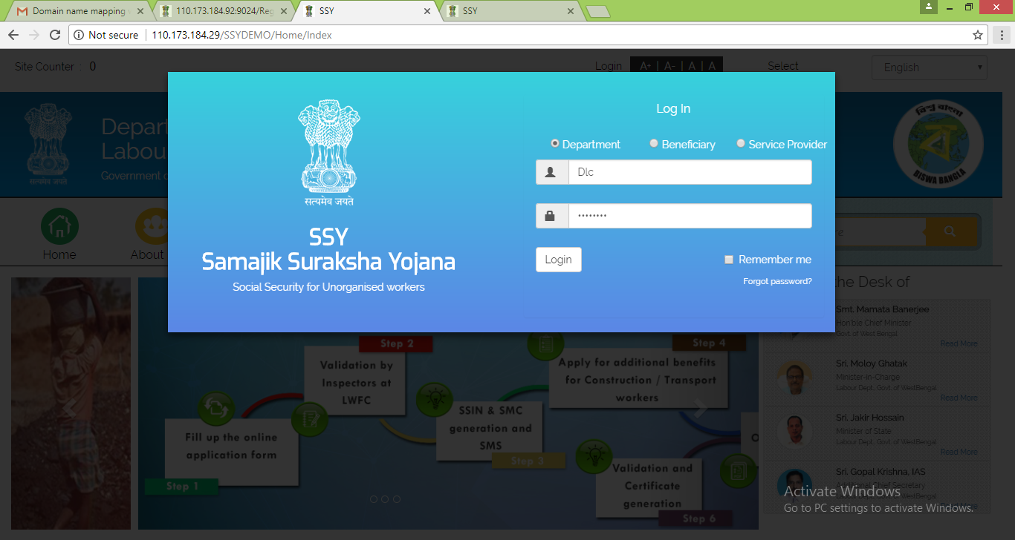

## 2.2 Dashboard

Upon successful login the Deputy Labour Commissioner is provided a dashboard for Scheme wise Received Details, Approved Details, Pending Details, Rejected Details, Total Application Request and SSY Card Issuance Status

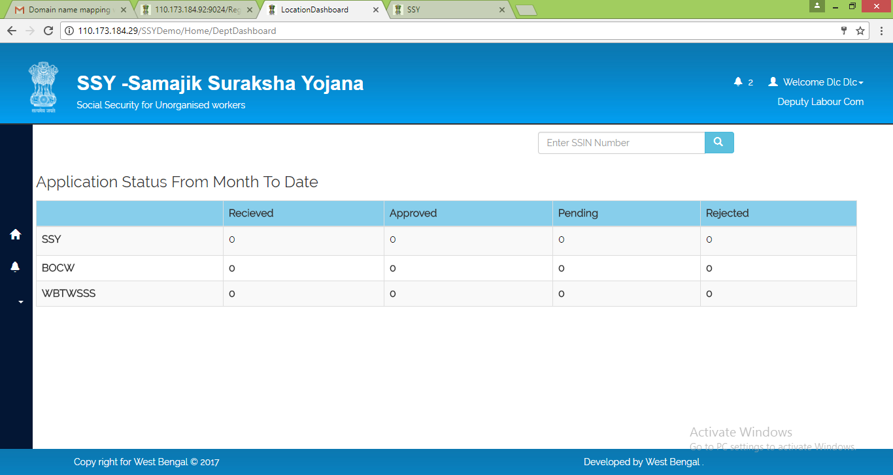

## 2.3 Reports

Requisite MIS Reports are provided under Reports section

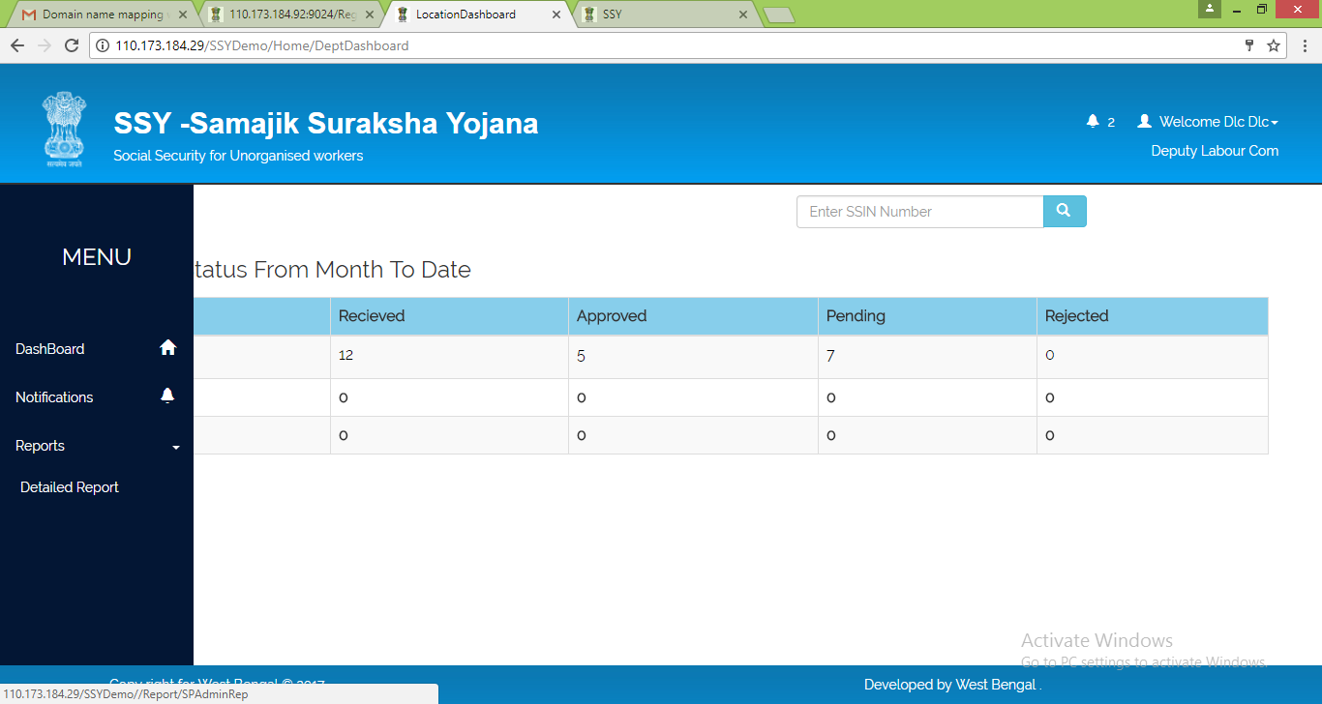

The DLC user can use the filters to generate reports as per requirement

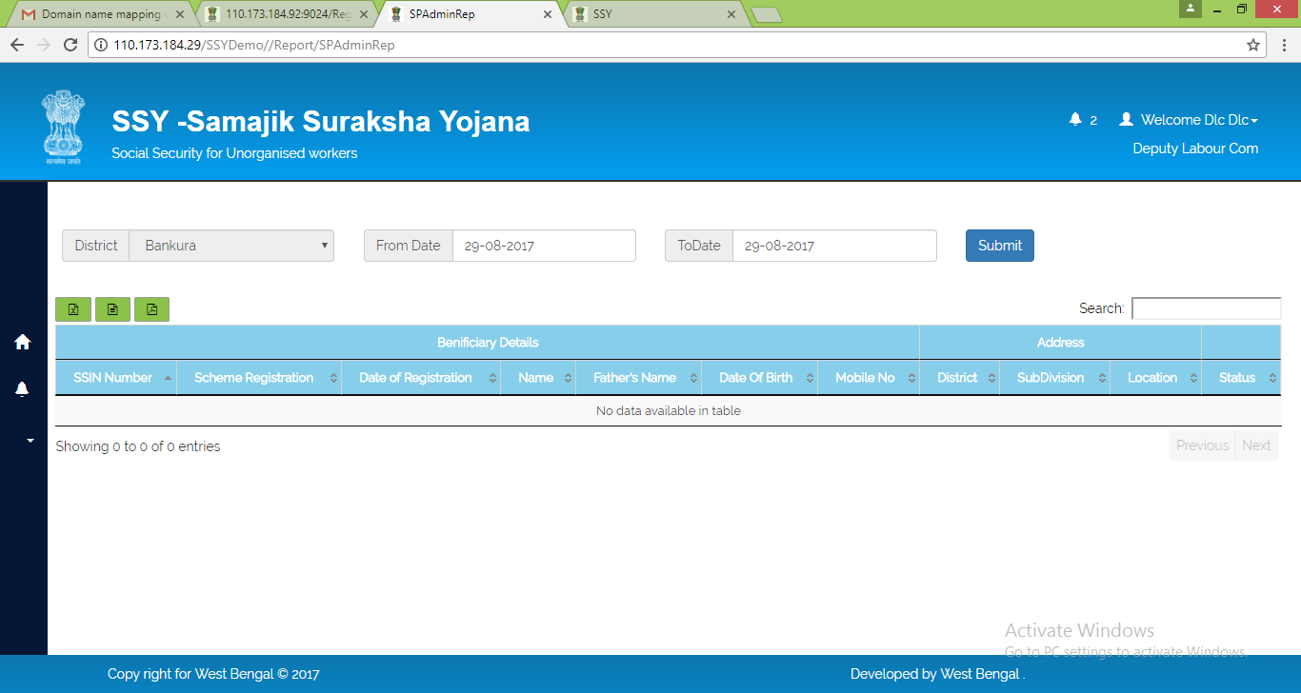

## 2.4 Notification

The Notification module can be used for following purposes

1. This module is to view Notifications and Circulars download  
2. User should able to view alert if any new notification is received

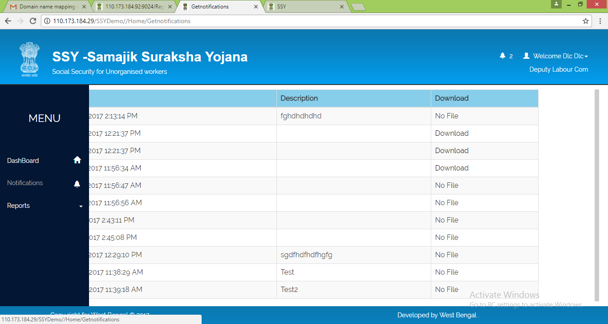

## 2.5 Edit Profile

|  |
| --- |
| The DLC user can access edit profile module and change password modules from top right corner of the dashboard itself |
| Edit Profile module could be used to change profile details   2.6 Change Password Change Password module is to update existing password with new password |

## 2.7 Beneficiary Registration

DLC can register beneficiary from their dashboard using the “Ben Registration” module



Under each of the three different registration options namely,

* Legacy 1 (Before 31'st March 2017 )
* Legacy 2 (After 1'st April 2017 )
* New Registration

user has option to choose between Bulk Upload or Single Registration



On selecting Bulk Upload the user is redirected to a page with detailed instruction about the bulk upload procedure



|  |  |  |
| --- | --- | --- |
| FIELD NAME | DESCRIPTION | REMARKS |
| Download Template | Button to generate beneficiary bulk upload format | * Clicking this button will download bulk beneficiary upload excel format file in user’s local system |
| Choose File | Upload location of duly filled in bulk beneficiary upload data file | * User can select path of his local machine where duly filled in bulk beneficiary upload data file is saved |
| Submit | Button to upload beneficiary bulk data in SSY database | * Clicking this button will upload the bulk beneficiary data file in SSY database |

On selecting Single Registration the user is redirected to a page from where single user registration can be done. Details of registration process are described as follows,

* New Beneficiary Registration (Refer Section 6.4 of this document)
* Existing Beneficiary Registration (Refer Section 6.3 of this document)

## 2.8 Logout

The DLC user can log out of the SSY application by clicking on the Logout link

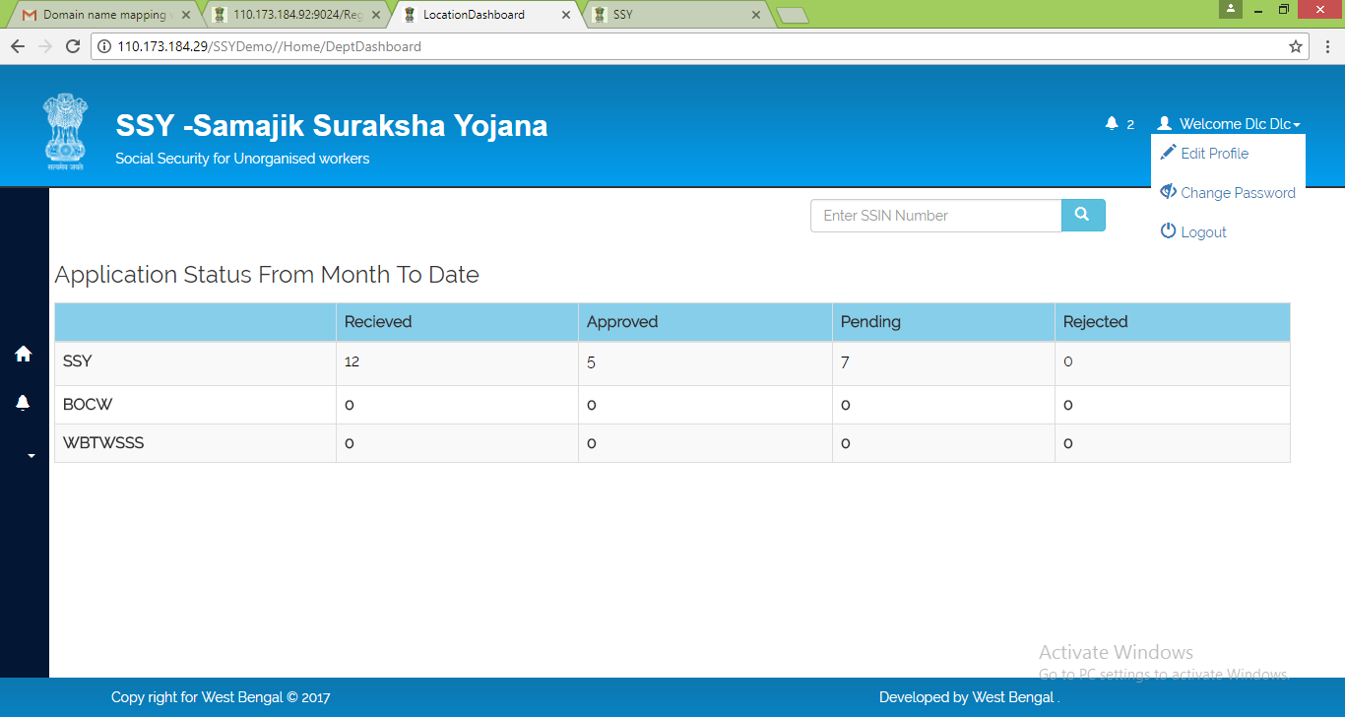

# 3. Assistant Labour Commissioner

## 3.1 Login

The Assistant Labour Commissioner can log into the SSY portal by clicking on the Login link in the homepage



This will bring up the login prompt as shown below. Being departmental user the ALC should select the Department option and input user id and password received through SMS and then click on Login button

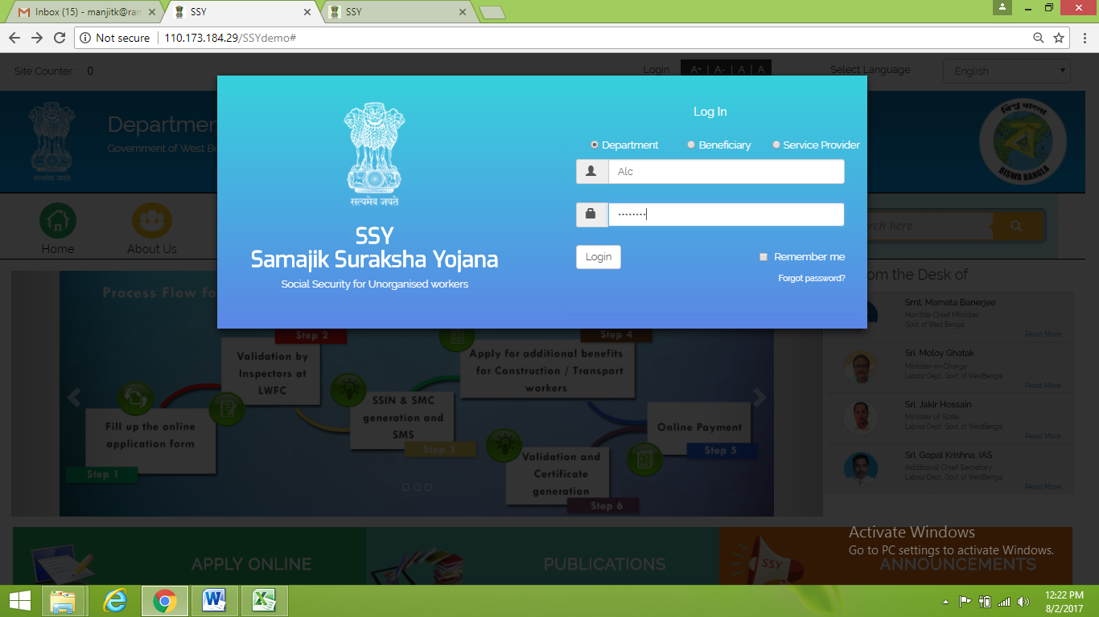

## 3.2 Dashboard

Upon successful login the Assistant Labour Commissioner is provided a dashboard for Scheme wise Received Details, Approved Details, Pending Details, Rejected Details, Total Application Request and SSY Card Issuance Status

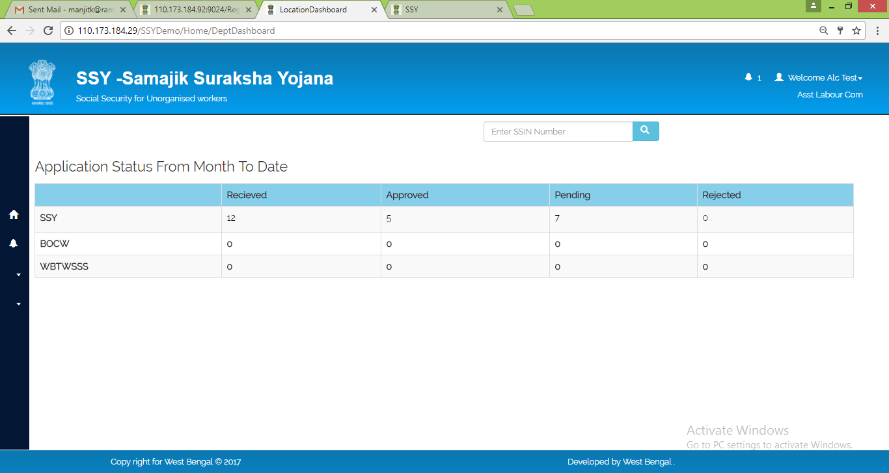

## 3.3 Registration

The ALC user can create SLO user through Registration->New User Registration

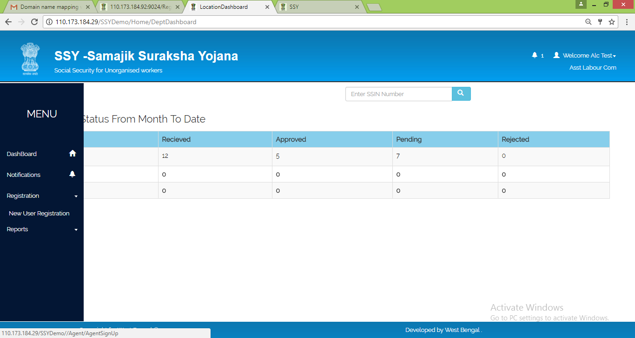

In the subsequent page the ALC user need to capture all the mandatory details and click on Register button to complete the registration process

|  |
| --- |
| 1. Capture Name, Mobile Number, e-Mail Id 2. Assign Location by selecting district, Sub-division |
| After Registration, SLO should upload requisite supporting docs ALC can verify application wise supporting docs and take decision to Approve or Reject from his dashboard. On approval, SLO should able to do other activities. On Request basis, SLO Application status can be verified with SLO Id |
| 3.4 Reports |
| Requisite MIS Reports are provided under Reports section    The ALC user can use the filters to generate reports as per requirement   3.5 Notification The Notification module can be used for following purposes |
| 1. This module is to view Notifications and Circulars download 2. User should able to view alert if any new notification is received |

|  |
| --- |
| The ALC user can access edit profile module and change password modules from top right corner of the dashboard itself   3.6 Edit Profile Edit Profile module could be used to change profile details |
| 3.7 Change Password Change Password module is to update existing password with new password |

## 3.8 Beneficiary Registration

ALC can register beneficiary from their dashboard using the “Ben Registration” module



Under each of the three different registration options namely,

* Legacy 1 (Before 31'st March 2017 )
* Legacy 2 (After 1'st April 2017 )
* New Registration

user has option to choose between Bulk Upload or Single Registration



On selecting Bulk Upload the user is redirected to a page with detailed instruction about the bulk upload procedure



|  |  |  |
| --- | --- | --- |
| FIELD NAME | DESCRIPTION | REMARKS |
| Download Template | Button to generate beneficiary bulk upload format | * Clicking this button will download bulk beneficiary upload excel format file in user’s local system |
| Choose File | Upload location of duly filled in bulk beneficiary upload data file | * User can select path of his local machine where duly filled in bulk beneficiary upload data file is saved |
| Submit | Button to upload beneficiary bulk data in SSY database | * Clicking this button will upload the bulk beneficiary data file in SSY database |

On selecting Single Registration the user is redirected to a page from where single user registration can be done. Details of registration process are described as follows,

* New Beneficiary Registration (Refer Section 6.4 of this document)
* Existing Beneficiary Registration (Refer Section 6.3 of this document)

## 3.9 Logout

The ALC user can log out of the SSY application by clicking on the Logout link

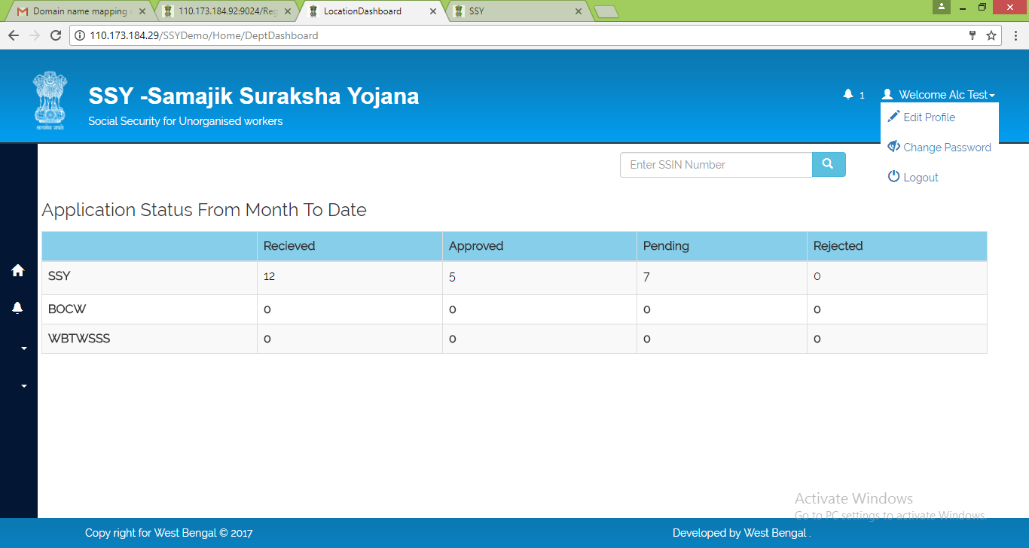

# 4. Inspector

## 4.1 Login

The Inspector can log into the SSY portal by clicking on the Login link in the homepage



This will bring up the login prompt as shown below. Being departmental user the Inspector should select the Department option and input user id and password received through SMS and then click on Login button

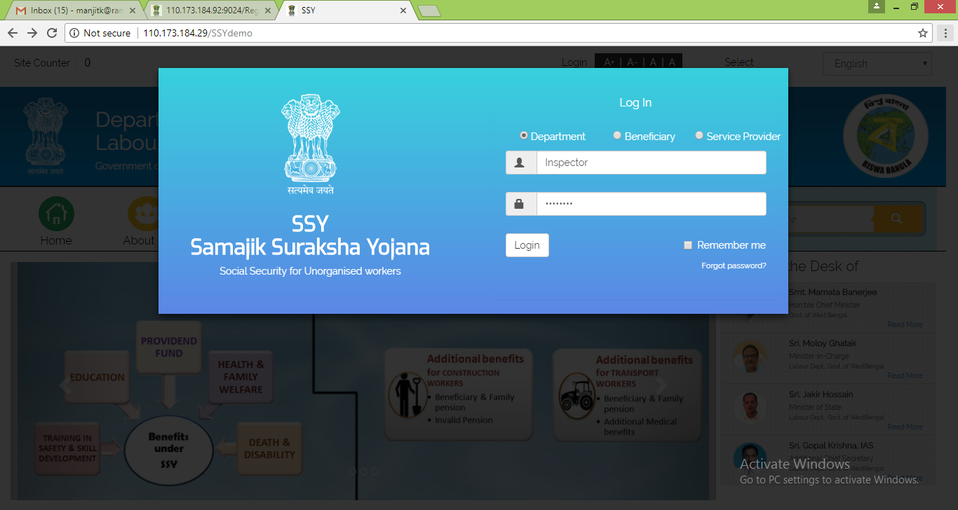

## 4.2 Dashboard

Upon successful login the Inspector is provided a dashboard for Scheme wise Received Details, Approved Details, Pending Details, Rejected Details, Total Application Request and SSY Card Issuance Status

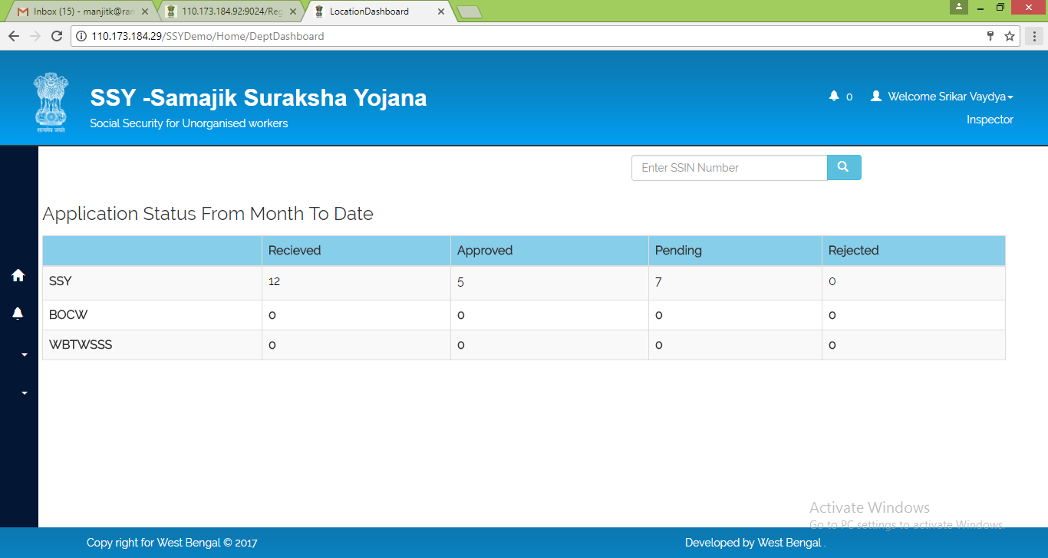

## 4.3 Application Status

1. Beneficiary Registration details will be binding to respective jurisdiction wise Inspector and can be viewed under Application Status module  
2. This Application Status module consists   
 a. Pending - Unattended Request

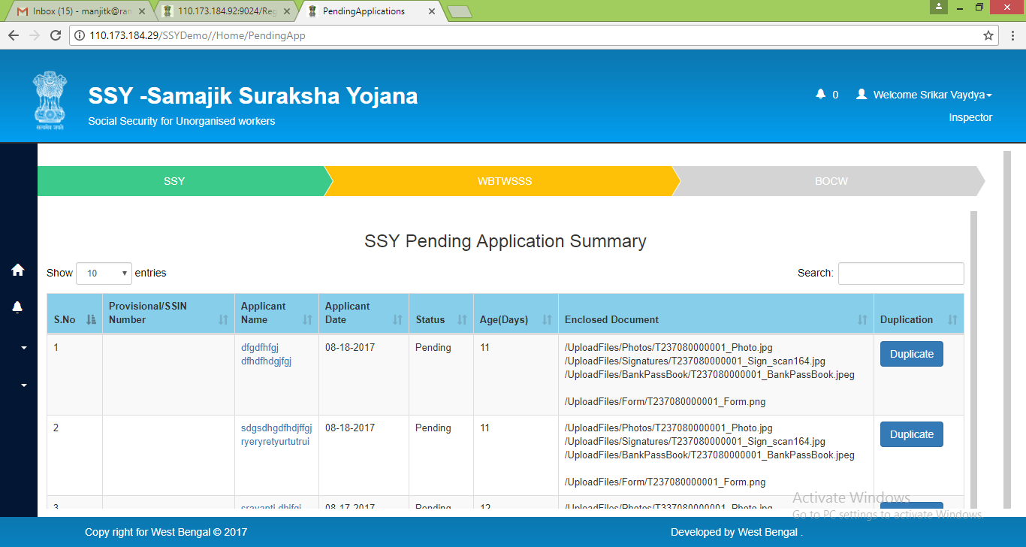

|  |
| --- |
| In case Application found duplicate entries with Registration details, application displays list of such records, out of which Inspector verifies and selects one to process for SSIN and remaining will get updated as futile |
| SSIN is a 12-digit number which comprises the following format 1st digit - Occupation Type  2nd and 3rd digits - RLO Code 4th and 5th digits - Location Code  6th digit (New) - Kept it as '0' value 7th to 12th digits - Location wise Running Number |

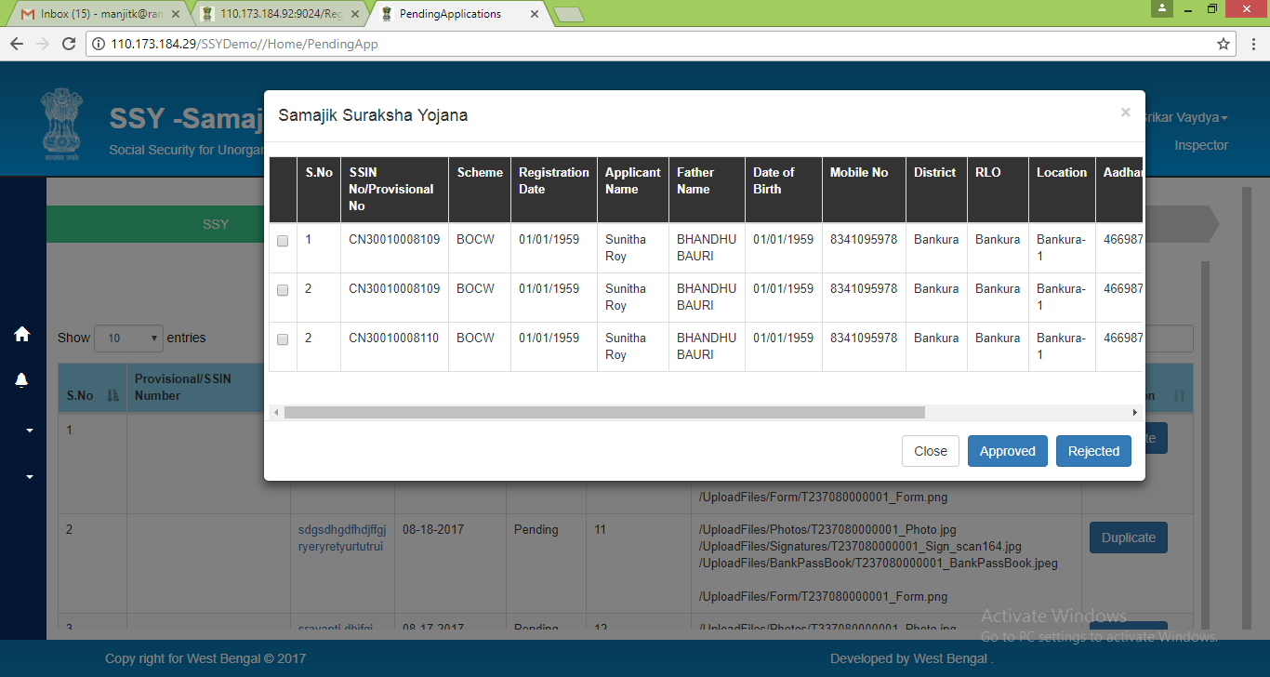

b. Approved - Verified and submitted for SSIN Generation

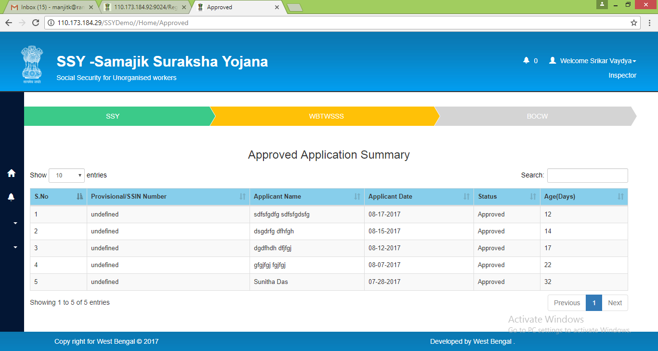

c. Rejected - Verified and rejected due to improper documentation, duplicate entry etc.

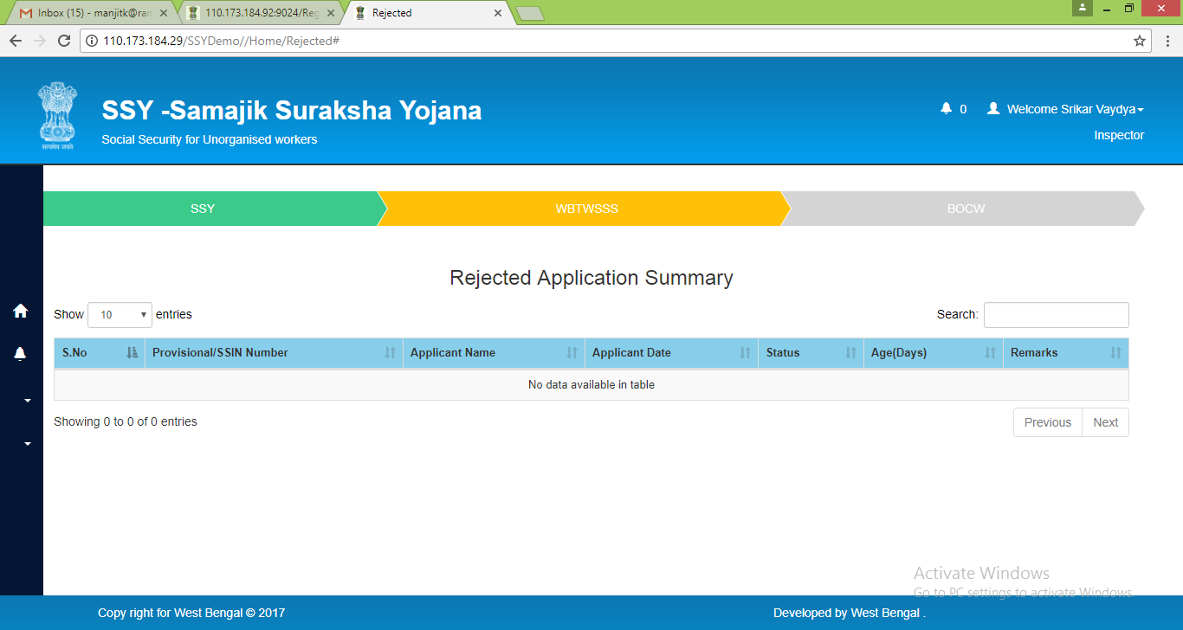

3. Inspector has to act on Registration Request, Verify the Registration details, Verify Uploaded docs by clicking on each applicant name

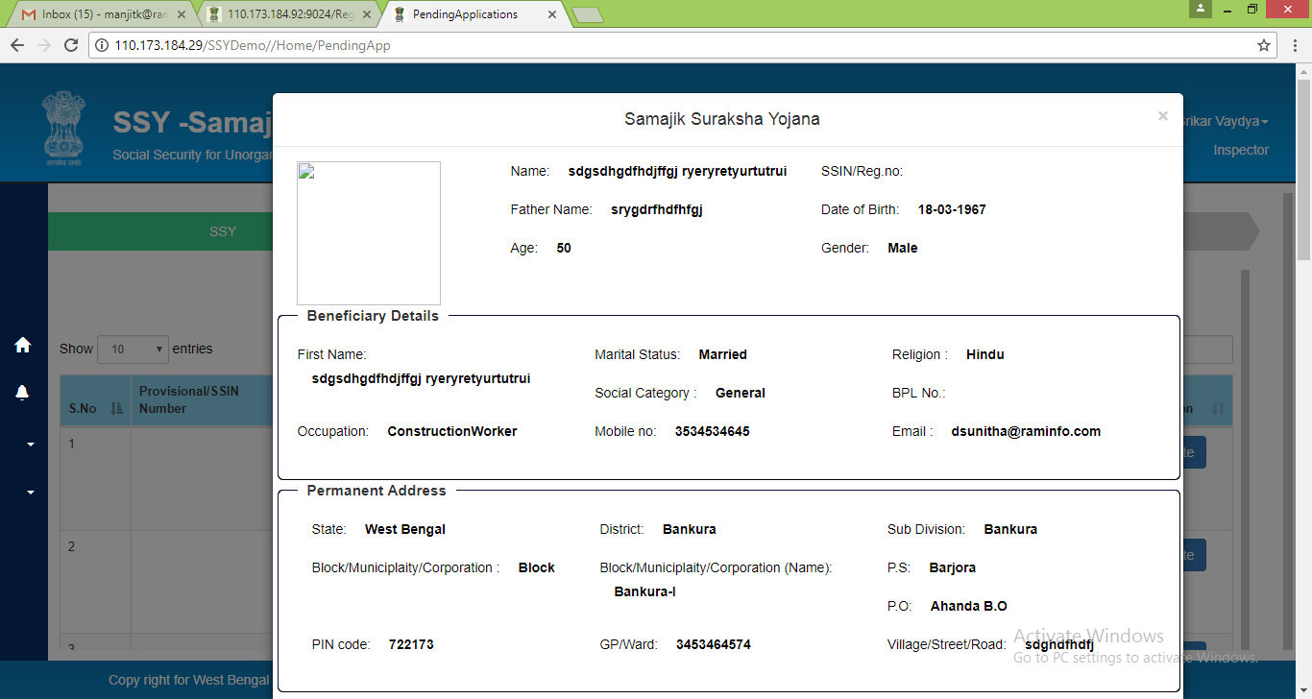

4. Based on application review the Inspector may decide accordingly and can choose to approve the application by clicking on Verified button or can also reject the application by clicking on the Rejected button

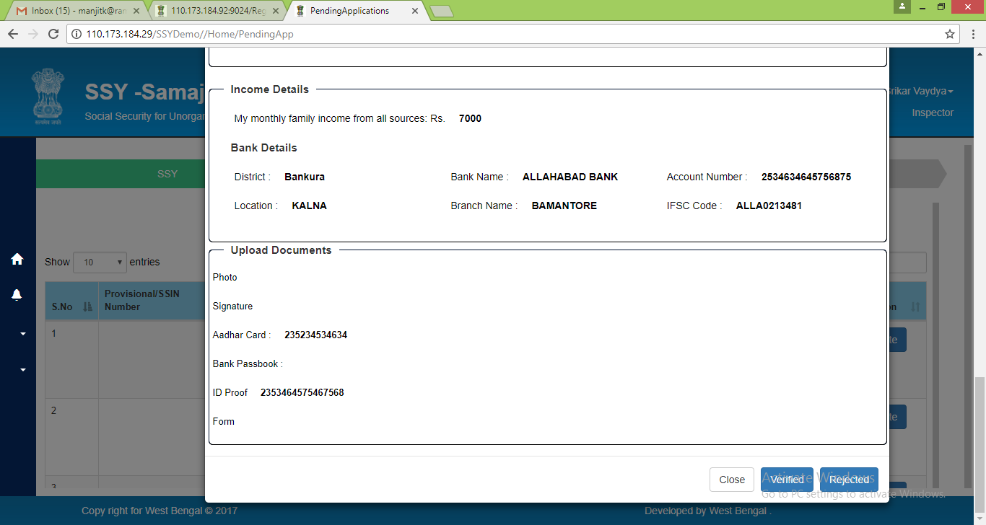

## 4.4 Reports

Requisite MIS Reports are provided under Reports section

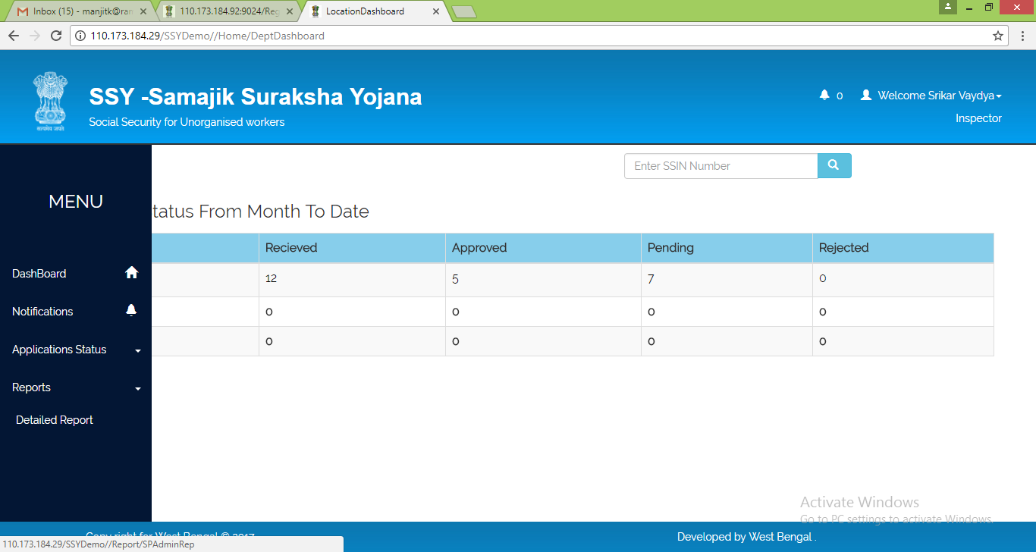

The Inspector can use the filters to generate reports as per requirement

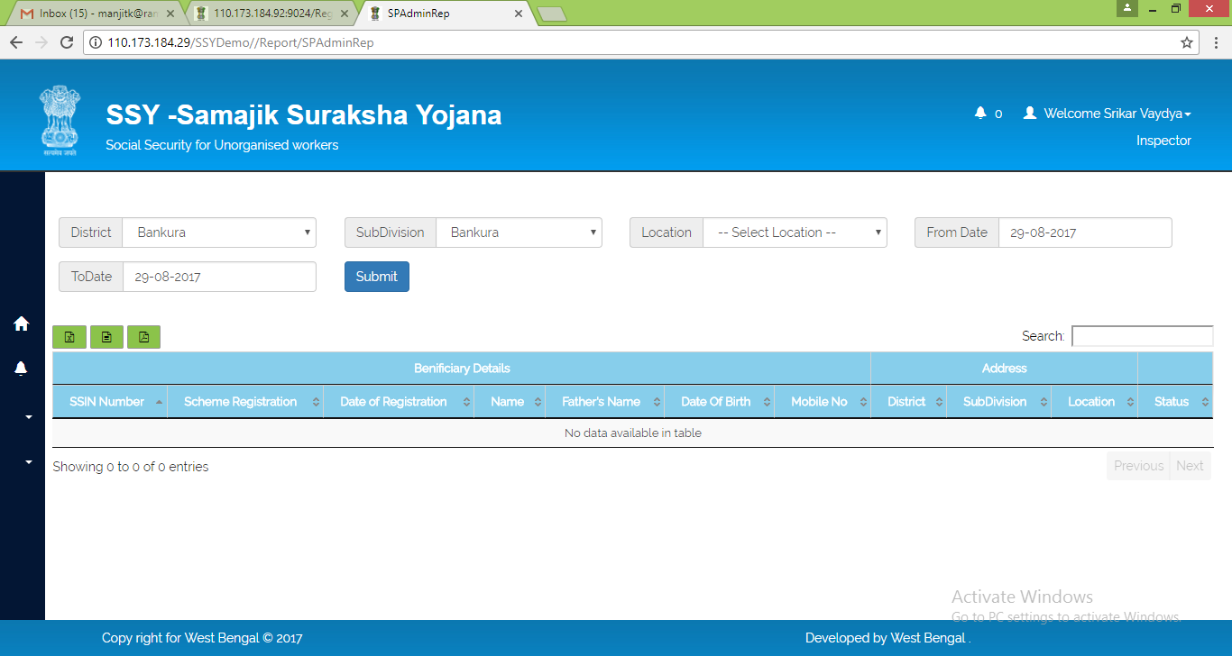

## 4.5 Notification

The Notification module can be used for following purposes

1. This module is to view Notifications and Circulars download  
2. User should able to view alert if any new notification is received

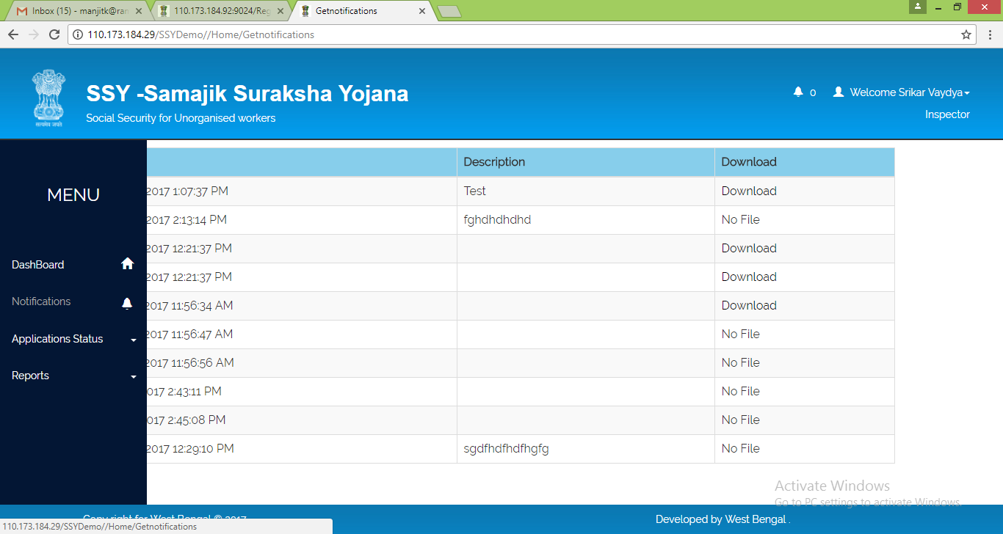

|  |
| --- |
| The Inspector can access edit profile module and change password modules from top right corner of the dashboard itself |
| 4.6 Edit Profile Edit Profile module could be used to change profile details   4.7 Change Password Change Password module is to update existing password with new password |

## 4.8 Beneficiary Registration

Inspectors can register beneficiary from their dashboard using the “Ben Registration” module



Under each of the three different registration options namely,

* Legacy 1 (Before 31'st March 2017 )
* Legacy 2 (After 1'st April 2017 )
* New Registration

user has option to choose between Bulk Upload or Single Registration



On selecting Bulk Upload the user is redirected to a page with detailed instruction about the bulk upload procedure



|  |  |  |
| --- | --- | --- |
| FIELD NAME | DESCRIPTION | REMARKS |
| Download Template | Button to generate beneficiary bulk upload format | * Clicking this button will download bulk beneficiary upload excel format file in user’s local system |
| Choose File | Upload location of duly filled in bulk beneficiary upload data file | * User can select path of his local machine where duly filled in bulk beneficiary upload data file is saved |
| Submit | Button to upload beneficiary bulk data in SSY database | * Clicking this button will upload the bulk beneficiary data file in SSY database |

On selecting Single Registration the user is redirected to a page from where single user registration can be done. Details of registration process are described as follows,

* New Beneficiary Registration (Refer Section 6.4 of this document)
* Existing Beneficiary Registration (Refer Section 6.3 of this document)

## 4.9 Logout

The Inspector can log out of the SSY application by clicking on the Logout link

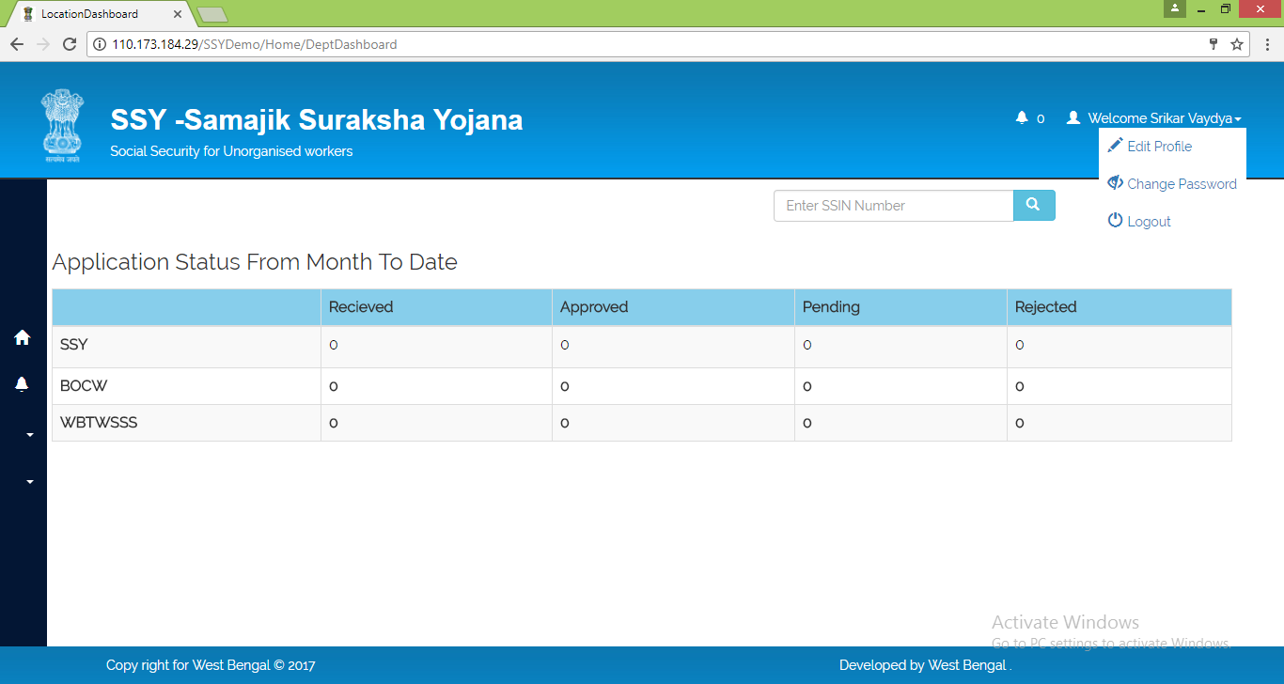

# 5. SLO

## 5.1 Login

After SLO Registration, User Credentials will be provided. SLO should upload requisite supporting documents to do further activities. SLO has to furnish Agreement, PAN, Proof of Id, Proof of Address, Bank Account etc. On getting Confirmation from ALC, Application should allow SLO to make Beneficiary Registrations etc.

The SLO can log into the SSY portal by clicking on the Login link in the homepage



This will bring up the login prompt as shown below. Being service provider user the SLO should select the Service Provider option and input user id and password received through SMS and then click on Login button

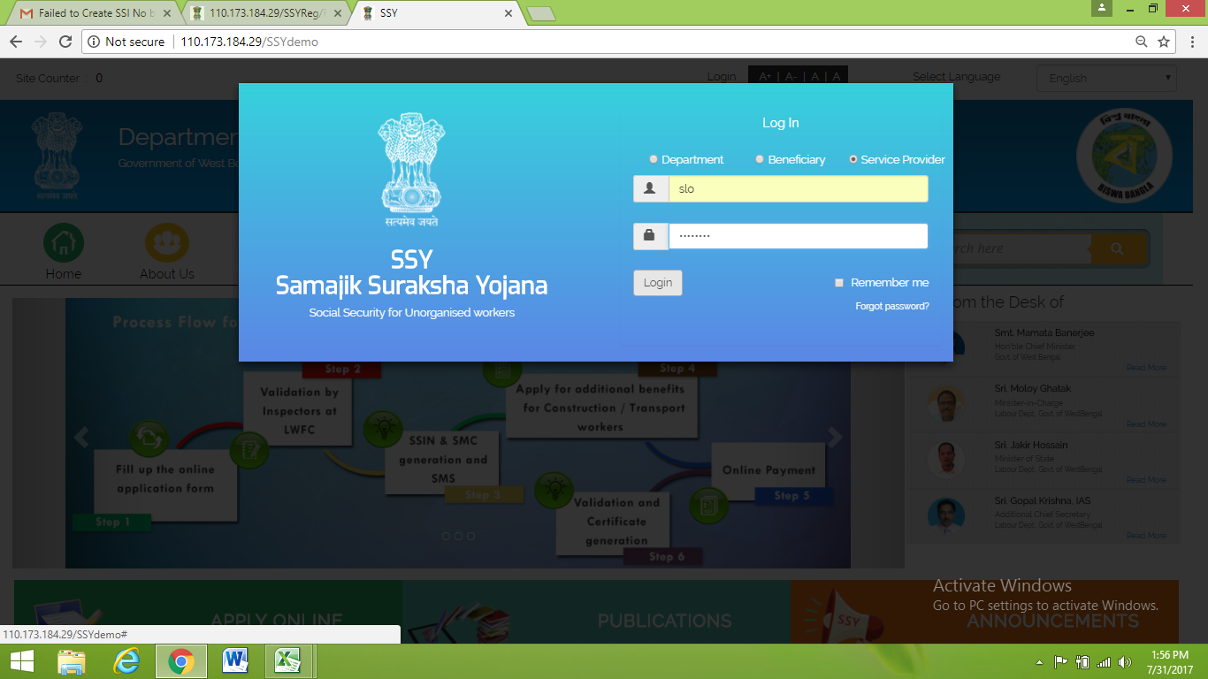

## 5.2 Dashboard

Upon successful login the SLO is provided a dashboard for Scheme wise Received Details, Approved Details, Pending Details, Rejected Details, Total Application Request and SSY Card Issuance Status

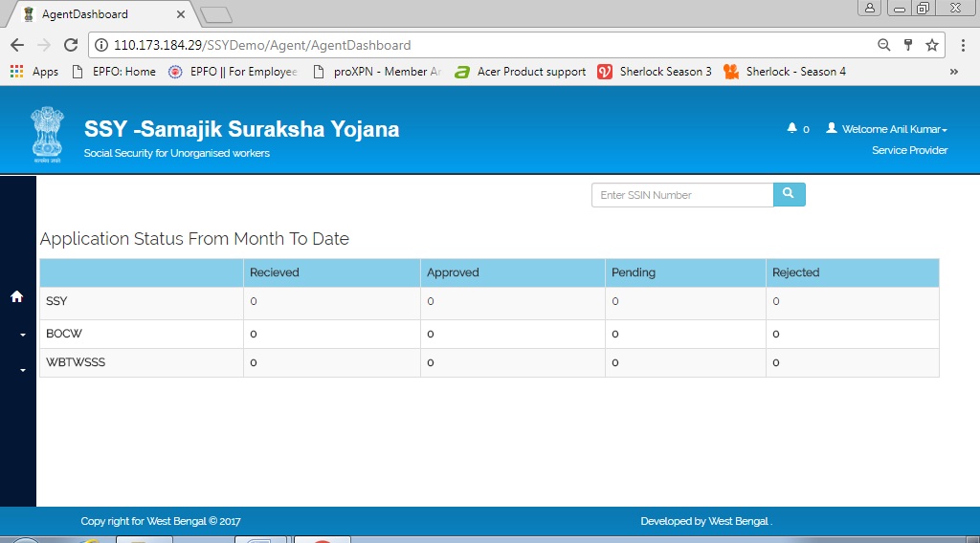

The SLO can perform the below mentioned activities

|  |
| --- |
| 1. On Request basis, Beneficiary SSY Scheme Certificate print out can be issued  2. On Request basis, Beneficiary SMC print out can be issued |
| 3. On Request basis, Beneficiary subscriptions can be collected 4. Search Beneficiary details with SSIN or Mobile Number 5. Collect the Subscription from beneficiary for Annual or Monthly basis 6. Available mode is Cash or dd.  7. Transaction Amount will be remitted to department account, T+1 (as agreed)  8. On request basis, SLO can verify the SSY Registration status with Mobile Number or SSIN for other scheme Status |
| 5.3 Reports Requisite MIS Reports are provided under Reports section   5.3.1 Payment Report The SLO can generate and view beneficiary payment details in this report   5.3.2 User Report The SLO can generate and view detailed beneficiary report in this section |
| 5.4 Registration The SLO can perform beneficiary registration activity from this module   5.4.1 Beneficiary Registration SLO can register beneficiary from their dashboard using the “Ben Registration” module    Under each of the three different registration options namely,   * Legacy 1 (Before 31'st March 2017 ) * Legacy 2 (After 1'st April 2017 ) * New Registration   user has option to choose between Bulk Upload or Single Registration    On selecting Bulk Upload the user is redirected to a page with detailed instruction about the bulk upload procedure     |  |  |  | | --- | --- | --- | | FIELD NAME | DESCRIPTION | REMARKS | | Download Template | Button to generate beneficiary bulk upload format | * Clicking this button will download bulk beneficiary upload excel format file in user’s local system | | Choose File | Upload location of duly filled in bulk beneficiary upload data file | * User can select path of his local machine where duly filled in bulk beneficiary upload data file is saved | | Submit | Button to upload beneficiary bulk data in SSY database | * Clicking this button will upload the bulk beneficiary data file in SSY database |   On selecting Single Registration the user is redirected to a page from where single user registration can be done. Details of registration process are described as follows,   * New Beneficiary Registration (Refer Section 6.4 of this document) * Existing Beneficiary Registration (Refer Section 6.3 of this document)   The SLO can access edit profile module and change password modules from top right corner of the dashboard itself   5.5 Edit Profile Edit Profile module could be used to change profile details   5.6 Change Password Change Password module is to update existing password with new password   5.7 Logout The SLO can log out of the SSY application by clicking on the Logout link   6. Beneficiary6.1 SSY Portal The beneficiary can find all the necessary information they need to know about Samajik Suraksha Yojana from the SSY Portal Home Page. The page is divided in following sub-pages.  1. Language Selection 2. Login 3.About SSY 4.RTI 5. Acts & Rules 6.Contact Us 7. Apply Online Registration 8. Publications & Notifications 9. Search option  C:\Users\RaminfoWB\Desktop\beedi-worker-homepage.jpg 6.2 Apply Online 1. This module allows unorganized workers to register with SSY Portal. 2. Both New and Existing Workers are able to access and register 3. New Worker has to provide complete details as per application form to submit Registration Process. 4. Existing user details are retrieved from legacy data and remaining mandatory information will be allowed worker to capture and submit the application. 5. On successful Registration, Workers receive Provisional Registration Number along with User credentials to access SSY Portal   6.3 Registration Process for Existing Beneficiary 1. In case the applicant is existing beneficiary they have to select “Yes” option in the First Page.    2. Then system will open up a page to key in Registration No, Father’s Name, Date of Birth. 3. Capture Scheme Registration Number to get Applicant details from legacy data in case of Existing applicant.      4. Capture Registration Form details which are not retrieved from legacy data and update with latest details. 5. Beneficiary has to furnish letter from Gram Panchayat, MLA etc. that he/she is unorganized worker. Without this Registration is not allowed 6. Upload supporting docs like Proof of Identity, Proof of Address, Bank Passbook, Passport Photo and signature/thumb Impression 7. On submission system will send OTP to the provided mobile number of the beneficiary. This OTP has to be entered in the OTP box and Submit Form needs to be clicked.  8. System will submit entire form to the server to complete the registration process. This might take some time depending on internet connection speed of the user.  9. Please do not close the browser window or hit browser back button before the entire process is successfully completed and registration success message is displayed on the screen. 6.4 Registration Process for New Beneficiary 1. In case the beneficiary is a new applicant they have to select “No” option in the First Page.    2. Then the system opens up Disclaimer page where they have to mention themselves as Unorganized Worker and agree to the disclaimer before clicking on Continue to proceed with registration.    3. In the next page blank registration form opens up in which they have to fill up all the necessary details as required for registration.  4. Capture Beneficiary details - Personal details, Mobile Number, Present & permanent address, Beneficiary Bank details, dependent details, Nominee details along with their Bank details 5. Beneficiary has to furnish letter from Gram Panchayat, MLA etc. that he/she is unorganized worker. Without this Registration is not allowed 6. Upload supporting docs like Proof of Identity, Proof of Address, Bank Passbook, Passport Photo and signature/thumb Impression        7. On submission system will send OTP to the provided mobile number of the beneficiary. This OTP has to be entered in the OTP box and Submit Form needs to be clicked.  8. System will submit entire form to the server to complete the registration process. This might take some time depending on internet connection speed of the user.  9. Please do not close the browser window or hit browser back button before the entire process is successfully completed and registration success message is displayed on the screen.    10. On successful submission of application system should generate Provisional Registration Number and User Credentials. Currently Mobile Number is considering as User Id. 11. Provisional Registration along with User Credentials should be sent to the Registered Mobile Number. 6.5 Login 1. Login Module is available under Home Page. 2. All types of users are accessible through this login, department, Beneficiary, Service Provider. 3. For Beneficiary, three types of User Ids can be used to login, SSIN, Mobile Number and Bank Account Number. 4. For SSIN User Id, System generate Password is used which can be updated after first login.  5. For Mobile Number and Bank Account Number, System generated OTP will be sent to Registered Mobile Number.   6.6 Dashboard 1. Beneficiary dashboard displays schemes availed details like Scheme Registration Number Registration date Scheme Name 2. On SSY Registration, SSY Certificate with SSIN and SMC will be binded which can take a print out      3. Based on the Worker type i.e. Construction, Transport and Others, Application maps list of schemes to the respective worker dashboard  a. For Construction Worker - BOCWA, PF, SSY are eligible  b. For Transport Worker - WBTWSSS, PF, SSY are eligible  c. For Others - PF, SSY are eligible 4. Worker can apply eligible schemes after SSY registration, else SLO can apply on behalf of respective worker using SSIN   |  | | --- | | The Beneficiary can access edit profile module and change password modules from top right corner of the dashboard itself | | 6.7 Edit Profile Edit Profile module could be used to change profile details   6.8 Change Password Change Password module is to update existing password with new password |  6.9 Logout The Beneficiary can log out of the SSY application by clicking on the Logout link |